APA 7th Edition Paper Template

Solomon Student
Liberal Arts, Excelsior University
TMP 101: Formatting
Professor Template
November 1, 2023

APA 7th Edition Paper Template
For even experienced students, formatting a paper can be a daunting task. The Excelsior Online Writing Lab created this template to give writers a foundation for formatting using the American Psychological Association (APA) guidelines. Throughout this essay, you’ll find helpful links to topics related to the APA and the essay writing process in general. For instance, in the opening paragraph of your essay, it’s important to create a strong thesis statement.
All APA papers begin with a title page. Beginning a few lines down on the first page, the title page starts with your essay’s title in bold. Following an extra space, the rest of your information is then listed. Your title page should include: your name, your program and institution, the class name, your instructor’s name, and the assignment’s due date. For more guidance on your title page and other facets of APA style, visit our APA Formatting Guide.
You will notice that we’ve chosen 12-point Times New Roman font for our template essay. Other standard fonts, such as Arial or Calibri, are perfectly acceptable. You’ll also notice that all our text—from the title page to block quotes—is double-spaced. The margins are set to 1 inch on all sides. A page number should appear in top right corner of every page (including the title page), placed flush with margin. The header can be accessed on most word processing programs by double-clicking or right-clicking on the top of the page.
Section headings are often used in APA writing to establish flow and organize information. First-level headings are centered, bolded, with all major words capitalized. (Note: you don’t need a heading at the beginning of your paper; that’s what your title is for.) While most APA papers call for first-level headings, there are several other heading levels for when information needs to be broken down further. We’ve included a first-level heading below. The OWL contains information on the other styles of headings and when to use them.
Quoting and Citations
Quoting from sources will probably be an important part of your essay. The Excelsior OWL has resources to help integrate quotes into your writing. In APA style, direct quotes can be incorporated in your paragraphs if they are shorter than 40 words. Remember to properly introduce and cite your quotations. For instance, if we were writing a paper on the importance of reading, a short quotation might come from a study by Bavishi, Slade, and Levy (2016) that “hypothesized that book reading provides a survival advantage, and that this advantage is mediated by cognitive engagement” (p. 4). In this example, because we’ve introduced the authors before the quotation, we don’t need to include them in the parenthetical citation. Also, pay special attention to the position of your punctuation as APA style is unique in that regard. The OWL has further guidance on how to format an in-text citation. Additionally, remember to cite not just direct quotations but paraphrases as well.
Excerpts longer than 40 words should be formatted in block quotations. Remember to introduce your block quote, typically with a sentence that ends with a colon. For instance, if we were continuing our essay on the importance of reading, we might deploy a block quote like this:
That immersion is supported by the way the brain handles language rich in detail, allusion and metaphor: by creating a mental representation that draws on the same brain regions that would be active if the scene were unfolding in real life. The emotional situations and moral dilemmas that are the stuff of literature are also vigorous exercise for the brain, propelling us inside the heads of fictional characters and even, studies suggest, increasing our real-life capacity for empathy.
None of this is likely to happen when we’re scrolling through TMZ. (Paul, 2013)
As you’ll notice above, block quotations are double-spaced just like the rest of the text. There are no quotation marks used with block quotes. The entire block quote should be indented a half inch. This can be accomplished by highlighting the block quote and pressing the ‘tab’ key. If you quote a passage that contains multiple paragraphs, those additional paragraphs should be indented an additional half inch.
If you are using figures like images, graphs, or tables in your essay, you have two options for how to present them. Figures can be incorporated directly into the text or included on separate pages following your reference list. Your figures should be numbered based on the order they appear in the essay, titled, and include a note that provides any necessary information or citation. Figures should appear at either the top or the bottom of the page; they can take up the entirety of a page if necessary. For more information on how to format figures, visit the APA’s website.

Figure 1
Your Brain on Books
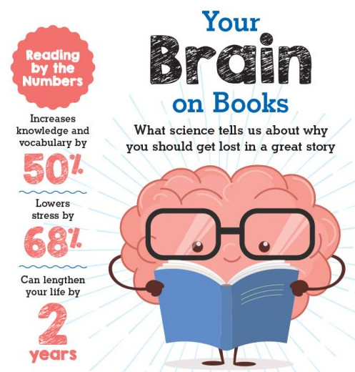
Note. Adapted from “Why reading is the best workout for your brain” by L. Lapaix, 2019, Scholastic Books, (https://oomscholasticblog.com/post/why-reading-best-workout-your-brain?linkId=64375734).
Finally, your essay should include a reference list that gathers all the sources used in your writing. Your reference list should be on a separate page with “References” centered in bold at the top. Your sources should be in alphabetical order by author’s last name. Each reference should have a hanging indent after the first line. On most word processing programs, a hanging indent can be created by highlighting the paragraph, selecting the “Paragraph” option, and then selecting the “hanging indent” option from the “special indentation” dropdown box. We’ve included a sample reference list at the end of this essay that includes the sources we used while buildings it as well as some common generic citation formats. You can find more information about constructing your Works Cited page at the Excelsior OWL.
In conclusion, as this template is preformatted to adhere to APA guidelines, students should feel confident simply deleting these paragraphs and replacing them with their own essay. For further assistance, please consult your instructor or visit the Excelsior OWL.

References
Author’s Last name, First and Middle initials. (Year of publication). Title of book. Publisher.
Author’s Last name, First and Middle initials, & Last names and initials of other authors, if any. (Year). Title of article. Title of Journal, volume number(Issue number), page numbers. URL or DOI link
Author’s Last name, First and Middle initials. (Date published or updated). Title of article. Site Name. URL
Bavishi, A., Slade, M. D., Levy, B. R. (2016). A chapter a day: association of book reading with longevity. Social Science & Medicine, 164, 44-48. https://doi.org/10.1016/j.socscimed.2016.07.014
The Excelsior Online Writing Lab. (n.d). APA references. https://owl.excelsior.edu/citation-and-documentation/apa-style/apa-references/
Lapaix, L. (2019, February 26). Why reading is the best workout for your brain. On Our Minds Scholastic Blog. https://oomscholasticblog.com/post/why-reading-best-workout-your-brain?linkId=64375734
Paul, A. M. (2013, June 3). Reading literature makes us smarter and nicer. Time. https://ideas.time.com/2013/06/03/why-we-should-read-literature/
Organization Name. (Year, Month Day). Webpage Title. URL.

